**1) download Smart SVN**

**2) skip all the hokey initial run options.  once you get the software open, click: <Project> <Check Out>**

**3) Paste the SVN url into the Repository field and hit continue**

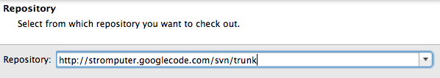

**4) You should see this, with the trunk directory highlighted.  Click Continue again**

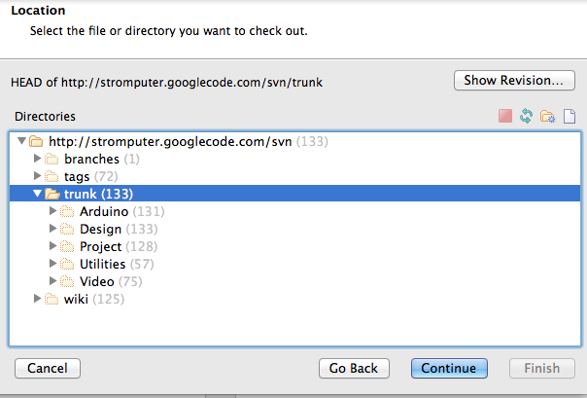

**5)Decide where you want to save it locally.**

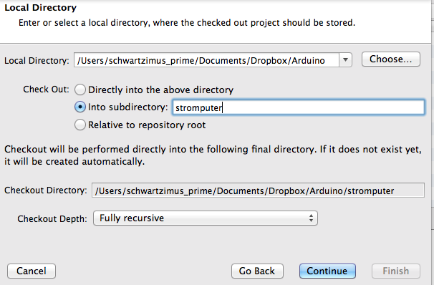

**6) On the last screen, choose Export only since you're just downloading the files from the SVN, not actively working on them.**

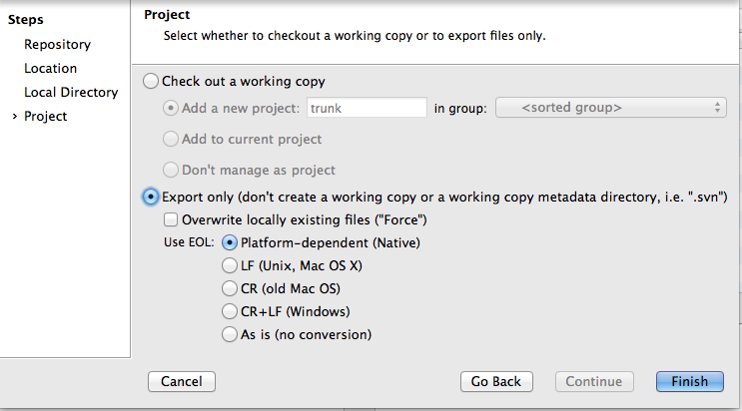

**7) You need to get the included libraries into the proper location on the Mac.**

**a) Copy all the library folders you got from the SVN**

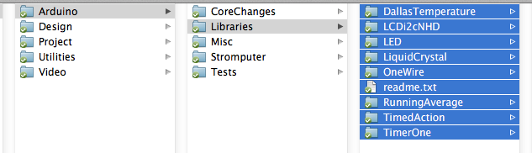

**b) put them into the Mac's hidey-hole location for libraries in   Documents/Arduino/Libraries**

